 March 13, 2013

**UPDATE – “L.O.U. 7” ARBITRATION**

A hearing was held in Toronto on March 12, 2013. Here is the interim order from Arbitrator Keller with regards to our “L.O.U. 7” grievance:

*The hearing dealing with the grievance was not able to be completed on the day scheduled and, consequently, further hearing days will be scheduled. During the course of the hearing, it became evident that certain information required for the hearing is confidential and/proprietary. To safeguard the information, I hereby Order that the persons present at the hearing keep confidential any and all information and documents used during, and for the purposes of, the hearing. This means that there can be no reporting of anything that took place or will take place during the hearing until an Award has been issued in this matter.*

The actual order will be posted later this week.

In Solidarity

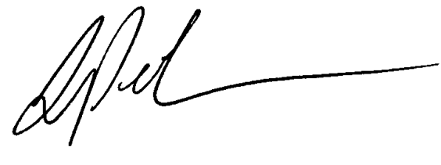

Lou Pagrach

General Chairperson

LP:cp



