 April 19, 2013

## We Have Won Again!

The IAM has once more defeated an attempt by the CAWU to overturn the democratic results of the representation vote of March, 2012, when you selected the IAM to represent you.

This time the CAWU appeal case was rejected by the Federal Court of Appeals.

Not only did we win this last appeal, but we were also granted damages by the court, which means that the CAWU has to pay the IAM’s legal costs of defending this case in court.

In addition to asking the Appeal Court to reverse the Labour Board (CIRB) decision for the IAM, the CAWU also asked to be given confidential information on the voting process.

These shameful requests were denied by the Federal Appeal Court.

We live in a democratic country, with laws designed to protect everyone’s privacy rights. We are shocked that the CAWU would try to get confidential voting information through the courts.

You can rest assured that the IAM, a professional union, respects the privacy of every individual we represent, as well as the laws of the land.

We continue to work to resolve your issues at work despite these distractions.

The CAWU have been given a clear message that they are not wanted anymore.

Let’s Continue to Work Together and Remain Solid!

In Solidarity

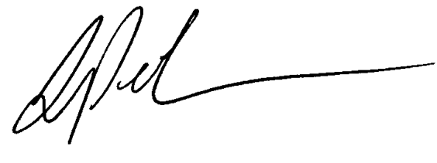

Lou Pagrach

General Chairperson

LP:gls