TO ALL MEMBERS OF THE IAMAW

ELECTION
GENERAL CHAIRPERSON (GARDA), CENTRAL REGION

Dear Brothers and Sisters:

As a result of the by-election held yesterday, September 12, 2013, Brother Barrington “Barry” Barnett has been elected to the position of General Chairperson (Garda), Central Region, effective from October 1, 2013, to September 30, 2017.

We would like to congratulate Brother Barnett on his victory. We would also like to thank Brothers Mir Alam, Duane Andrewes and Robert Craig, Sisters Caterina Barone and Sandra Hughes, who also stood for election.

In solidarity,
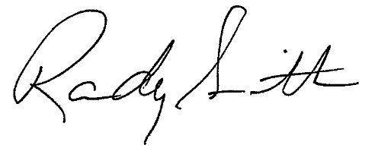

Randy Smith

Secretary-Treasurer

Transportation District 140, IAMAW

RS/ej



BULLETIN NO. 082 – ISSUED SEPTEMBER 13, 2013
PLEASE COPY, POST AND CIRCULATE

