OXFAM Honours IAM for Philippines Relief Contribution!

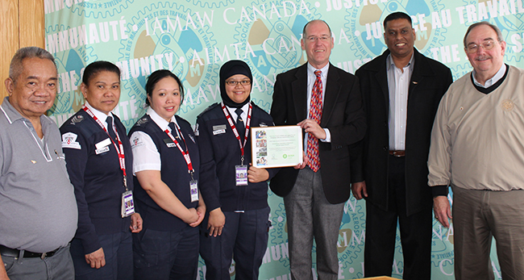

OXFAM thanks IAM Canada

The Executive Director of Oxfam Canada, Robert Fox, presented IAM Canada with a commemorative plaque in recognition of the Union’s contribution towards Oxfam’s relief and reconstruction work in areas of the Philippines devastated by Typhoon Haiyan on November 8, 2013. Joining IAM Canadian General Vice President Dave Ritchie in accepting the honour were members of the IAM Canada Philippine community. (Left to right) Manny Crescencia, Angeles De Guzman, Arlene Danota, Rowena Bicera, Robert Fox – Oxfam Executive Director, Barrington Barnett, and GVP Dave Ritchie

Toronto, ON – Oxfam Canada honoured Canadian Machinists in recognition of the generous contribution made towards Oxfam’s relief efforts in areas of the Philippines devastated by Typhoon Haiyan on November 8, 2013.
The IAM Canada donation of $50,000.00 matched the highest amount donated by any union within the Canadian movement. More than $600,000.00 was donated to Oxfam’s relief efforts by unions across the country. “We were very, very pleased at the tremendous generosity and support from the IAM,” said Oxfam Canada Executive Director Robert Fox. “The Machinists played a critical role, a leadership role within the Canadian Labour movement. They matched the highest donation from any union to this disaster and it reflects a history where the Machinists have been there when there have been major disasters around the world supporting the response.” IAM Canada answered the call with a $25,000.00 donation to Oxfam Canada in 2004 to support its relief efforts in the tsunami –shattered regions of Asia.

Also on hand at the presentation ceremonies were members of the IAM Philippine community. Manny Cresencia of IAM Local Lodge 717T, a retiree from Magellan Aerospace was joined by Airport Security Screeners Angelas De Guzman, Arlene Danota and Rowena Bicera, members of IAM Local Lodge 2921. Their employer, Garda Security Incorporated graciously gave them time off work to attend the presentation. Also in attendance was Barrington Barnett, IAM District Lodge 140 General Chairperson responsible for the airport security screeners. The reason for the donation was best summed up by IAM Canadian General Vice President Dave Ritchie. “Our motto is justice on the job and service to the community and I think it’s important that the community needs to know that the union is there for everybody and we’re responding on the basis of need and let me tell you, there is a terrible need in the Philippines right now,” he said.

To date, Oxfam has reached 500,000 of the worst affected people with life-saving supplies. Making sure people have clean water, safe sanitation and a roof over their heads is Oxfam's immediate priority.

