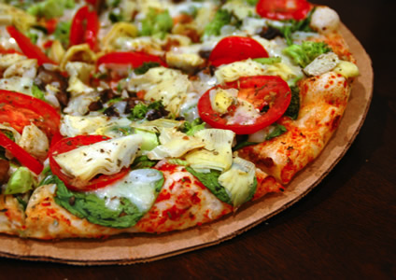

BARGAINING KICK OFF
Lunch Provided (Pizza and Drinks)

Wednesday August 27, 2014
Terminal 3 Union Office ( AT Level)
10:00 – 20:00

Thursday August 28, 2014
Terminal 1 Union Office (Domestic Arrivals)
10:00 – 20:00

Friday August 29, 2014
Terminal 5
10:00- 20:00

Come one, Come All
Everyone is Welcome
(Terminal 1, Terminal 3 & Terminal 5)
Toronto Screeners

